**CURRICULUM VITAE**

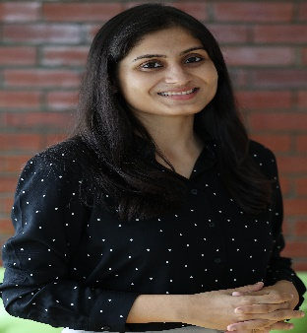

Jayshree Patnaik

Assistant Professor

Department of Entrepreneurship Management

Indian Institute of Technology Hyderabad (IITH), India

Email: [jpatnaik@em.iith.ac.in](mailto:jpatnaik@em.iith.ac.in)

**Bio**

Jayshree Patnaik is an Assistant Professor in the Department of Entrepreneurship and Management at the Indian Institute of Technology Hyderabad (IITH). She holds a Ph.D. from IIT Kharagpur in the area of Engineering Entrepreneurship. Her current research work looks at Appropriate Technology, Design Thinking, Frugal Innovation, Social Entrepreneurship, Innovation Management and Entrepreneurship. She has also published several research papers in international reputed journals and presented at renowned conferences.

**Academic Background**

* Ph.D. - Rajendra Mishra School of Engineering Entrepreneurship (RMSoEE), IIT Kharagpur

Thesis- Revisiting Appropriate Technology and its Relevance in Developing Country Context: An Empirical Study

**Teaching:**

* Introduction to Entrepreneurship
* Social Entrepreneurship
* Fundamentals of Design Thinking
* Innovation Management
* Technology Entrepreneurship

**Research Publications**

* Role of Academic Initiatives for Technology Management at the Base of the Pyramid: Empirical Evidence from India. International Journal of Innovation and Technology Management, 2250015.
* Analyzing appropriateness in appropriate technology for achieving sustainability: A multi-sectorial examination in a developing economy. Journal of Cleaner Production, 131204.
* Determining appropriateness for management of appropriate technology: an empirical study using factor analysis. Technology Analysis & Strategic Management, 1-13.
* Promise of Inclusive Innovation: A Re-look into the opportunities at the grassroots. Journal of Cleaner Production, 259, 121124.
* Revisiting Appropriate Technology with changing socio-technical landscape in emerging countries. Technology in Society, 57, 8-19.

**Conference Presentations**

* Innovation through hub and spoke model: E- Commercializing Regional India’s Handicraft Industry. 15th European Conference on Innovation and Entrepreneurship (ECIE) (pp. 614-622).
* Practices of Innovation Management Enabling Technology Adoption and Diffusion at the Grassroots. In 2019 IEEE International Symposium on Innovation and Entrepreneurship (TEMS-ISIE) (pp.1-6).
* Innovation Management in A Constraint Environment: Challenges in The Age of Sustainability. The European Proceedings of Social & Behavioural Sciences (pp.101-112).
* Appropriate Technology and Management for Sustainability. In 2018 IEEE International Conference on Industrial Engineering and Engineering Management (IEEM) (pp.1289-1292).

**Contact**

Department of Entrepreneurship and Management,

Indian Institute of Technology Hyderabad (IITH)

Kandi, Sangareddy - 502285

Email: [jpatnaik@em.iith.ac.in](mailto:jpatnaik@em.iith.ac.in)

#Kindly send me an email for scheduling an appointment.